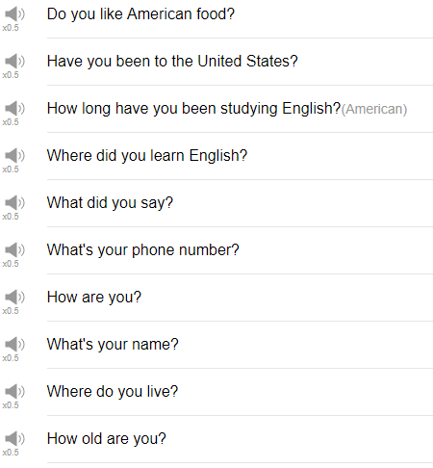

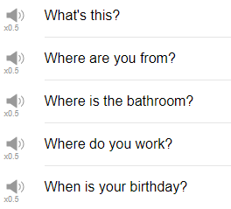

|  |
| --- |
| Why is the Jurassic Park theme song coming up? Hi, everybody my name is Alisha and today we're gonna be talking about 15 questions that you should know. So these are 15 question that not necessarily you need to know how to ask them perhaps you know some of the questions already but you will probably also hear these questions as well, so we'll practice a few different answers to these questions, too. So let's get started! |
| 1. Do you like American food? |
| The first question is "do you like American food?" you will probably be asked this question do you like American food? you can either say yes, or a no, or you can give a specific example. If someone says "do you like American food?" Yes, I love philly cheese steaks. I would recommend saying yes, or a little, or you can just say "I don't know, what do you recommend?" |
| 2. Have you been to the United States? |
| The next question is "have you been to the united states?" |
| "Have you been to the United States?" So someone asks you "have you been to the United States?" You should reply with either yes, I have; or no, I haven't; or maybe no, I haven't yet, but I want to. When you want to ask someone this question you can say "have you been to Japan?" "Have you been to Egypt?" "Have you been to china?" Whatever, you can use your own country when you ask this question |
| 3. How are you? |
| How are you? when someone asked "how are you?" don't say I'm fine, thank you, and you. Please don't say that, please say something more natural like good, great, I'm good, how are you? something like that is much better than I'm fine, thank you, and you. Be a little more genuine in your reply. Also when you ask this question maybe you wanna point out to sound a little more natural when you ask someone else don't, like, try to say "how are ya?" "how are ya?" instead of "how are you?" or, and make make sure your intonation is correct, I've had a few people ask me "how are you!" like a little too... with this question I like HOW are you but "how ARE you" should be the intonation with this. How are you? How are ya? It's a little bit more natural. |
| 4. How long have you been studying English? |
| Great question to know the answer to, your answer should be I have been studying English for blah blah blah years or blah blah blah months, or blah blah blah weeks. But if that's too much for you, you can just use the time. "How long have you been studying English?" "6 years." How long have you been studying English? "2 months." So just pick the time if the whole sentence is quite long for you. |
| 5. How old are you? |
| We don't really go around asking people how old they are, just the first time you meet them necessarily, especially if they're older, much older than you, like in particular, it's sometimes considered rude to ask, especially, women how old they are. So just be careful with this question, but if you're about the same age group, you know, maybe, you're an event, or a party or something, and you just wanna check how old the other person is, you can use this phrase. When you reply to this, just say "I'm" plus the number, to make a really simple response. "How old are you?" "I'm 15." "How old are you?" "I'm 42." Whatever the answer is, just stick "I'm" in front of it, not "I", but "I'm", "IM". But use the contracted form to sound more natural "I'm (number)." if you want to make a full sentence, you can say "I'm (number) years old." Don't forget that s in years. I'm a million years old. |
| 6. What did you say? |
| If you couldn't quite hear something that someone else said you can use this question to confirm sorry, what did you say? it's a little nicer than just saying "what?" What did you say? or what did you just say?" Sorry what did you say? I couldn't hear you. |
| 7. What's this? |
| When you don't know what something is, "what's this?" when you're out for dinner, you're out for lunch or something, and you find a new food or you're just curious just say "what's this?" To reply to this question just say "it's blah blah blah." |
| 8. What's your name? |
| Of course you should know how to ask this question and how to answer this question. "What's your name" is a little more natural than "what is your name". Again, contracted form will help you sound much more natural. So "what's your name?" someone asks you, you can just give your name "Alisha." That's fine, you can say Alisha. Or you can say "I'm Alisha" that's fine, too. you could say "my name is" or "my name's Alisha", either any of those are fine. In a more formal situation, business situation I would use "my name is" blah blah blah, and shake hands or something. |
| 9. What's your phone number? |
| The next one is "what's your phone number?" I would not ask this question right away like, maybe, you've met the person a few times, but you'd like to contact them whether it's because you're romantically interested in them, or because you want to be better friends with them but just if you meet someone for the first time and you're like "what's your phone number?" It's a little... a little too much. So use this question after you've met the person a few times, and you know you want to become better friends. When you want to give your phone number, just say "it's" and the number. That's fine just "it's..." or "my phone number is ..." with the number 551 million 526. |
| 10. When is your birthday? |
| So maybe you want to plan a birthday party, for example, or it's just another fun question the first time you meet someone. When is your birthday? So when you want to tell someone your birthday, just gives the month and the date. January 15. August 42nd. It's a real day. If you want to make a full sentence, you can save "my birthday is (month, date)." |
| 11. Where are you from? |
| The next word, the next question is "where are you from?" This can refer to your country, or your city, but I feel like probably it mostly refers to your country. So "where are you from?" your answer should be "I'm from (place)." "I'm from China." "I'm from Japan." "I'm from vietnam." I'm from America. Whatever, "I'm from..." |
| 12. Where did you learn English? |
| The next question is "Where did you learn English?" If you're speaking great English you can say I learned English at EnglishClass101.com! Coz you did, coz you're watching now! Anywhere, "where did you learn English?" In this case, in the case of these videos, "I learned English online." Or "I learned English from", and then the school name or the program name. So I learned English from EnglishClass101.com, for example. If he studied English at university, you can say "I learned English at university" or "I learned English from my friends," perhaps. |
| 13. Where do you live? |
| Depending on the situation where you're asked, this could mean your country, like "I live in America." "I live in China." Sometimes it's about the place in the city where you live, sometimes it's about the country where you live. So, you can kind of feel, I think, which question which type of questions being asked. |
| 14. Where do you work? |
| Where do you work is talking about your job. You can use the pattern "I work at (company name )." or "I work for (company name )." Either is fine. I work at ABC company, I work for ABC Company, either is ok. But, you know, if you have answered with the wrong information, the other person will just ask you, like, "oh I mean where is your office," or "oh I mean which company do you work for?" Use the Force for this one. |
| 15. Where is the bathroom? |
| Very important question! Where is the bathroom. In American English "where is the bathroom" or "where is the restroom" is more common than "where is the toilet" using the word toilet is a little bit too direct in American English. So I recommend "bathroom" or "restroom." |
| So those are 15 questions that you should definitely know. Know how to ask these questions, and know how to answer these questions. They're very useful and very important for everyday conversation. Thanks very much for joining us, thank you very much for subscribing; if you haven't subscribed yet please be sure to do so, so that you can check our fun stuff every week. With that, we will see you again next time, Bye! |
| If you are a baby watching this video please contact us because you're amazing! |